Final Project Design Phase
Computer Science - Week 11
Oct 3, 2026 - Version 0.0.4

For complete instructions and project ideas, refer to the assignment in Canvas. Specifically, review the final project requirements before you continue below. If you have not reviewed the project requirements in Canvas (you might have to go to the modules view and check the current or past week's content), you will not be able to properly complete the parts below. In addition, it may be helpful to review the information on this Drafter documentation page.

0) Project Planning and Preparation
Successful programmers spend time planning before they begin coding. After reviewing the project requirements, answer the following questions to help guide your design and development process.
- What concepts from class or previous assignments might help you complete this project? Which programming concepts (loops, conditionals, lists, classes, etc.) do you expect to use? What programming skills do you want to improve while completing this project?
Previous assignments on Drafter will help me complete this project, as I can use them for reference. I expect to use loops, if statements, lists, and dataclasses for this project. I want to improve my skills with Drafter while completing this project.

- Which parts of the project do you expect to be the easiest for you? The hardest? Why?
I think the easiest parts of the project will be the input and overall execution of the program, since I’ve had practice with those. I think the hardest parts will be the visual aspects and Drafter code, since I’m less familiar with those things.

- Even though you have not yet designed the final project, estimate which tasks will likely require the most time and effort? Which features or components should be implemented first?
I think implementing visual elements and Drafter components will take the most time and effort. I think I should first implement the user’s input and a way to neatly store information, and then focus on making the site look better.

- What distractions might interfere with your work and how will you minimize them? What resources will you need available while working? What questions, if any, do you still have about the assignment requirements?
I may be distracted from my work by work from other classes. I will minimize those distractions by doing assignments earlier and putting specific time aside to work on the project. If I need help, I will attend TA office hours or ask for help in the Discord. I do not have any questions about the assignment requirements!

1) Site Diagram
Create a mock-up of your planned website. We suggest you make the mockup on paper, although you can also use software like PowerPoint or Slides to make a mockup. There is other design software that could also be used, but we strongly encourage you to keep it simple. Do not spend more than 15-30 minutes detailing the mock-up. Your goal should be to make a very quick and dirty diagram, to show that you have some kind of idea.

We recommend drawing each page as a rectangle, and laying out the text, buttons, and other components inside. Then, use arrows to indicate links between pages. Label each page the way you will name each function, and then put labels on the arrows to indicate what the button links. Also write down any parameters that should come into the pages.

In addition to the pages and routes, write down what fields your `State` will have, both their names and types. Think clearly about what data will need to be persistent across the entire website.

Add photo(s) or screenshot(s) of your website mock-up and labeled diagram on the next page.

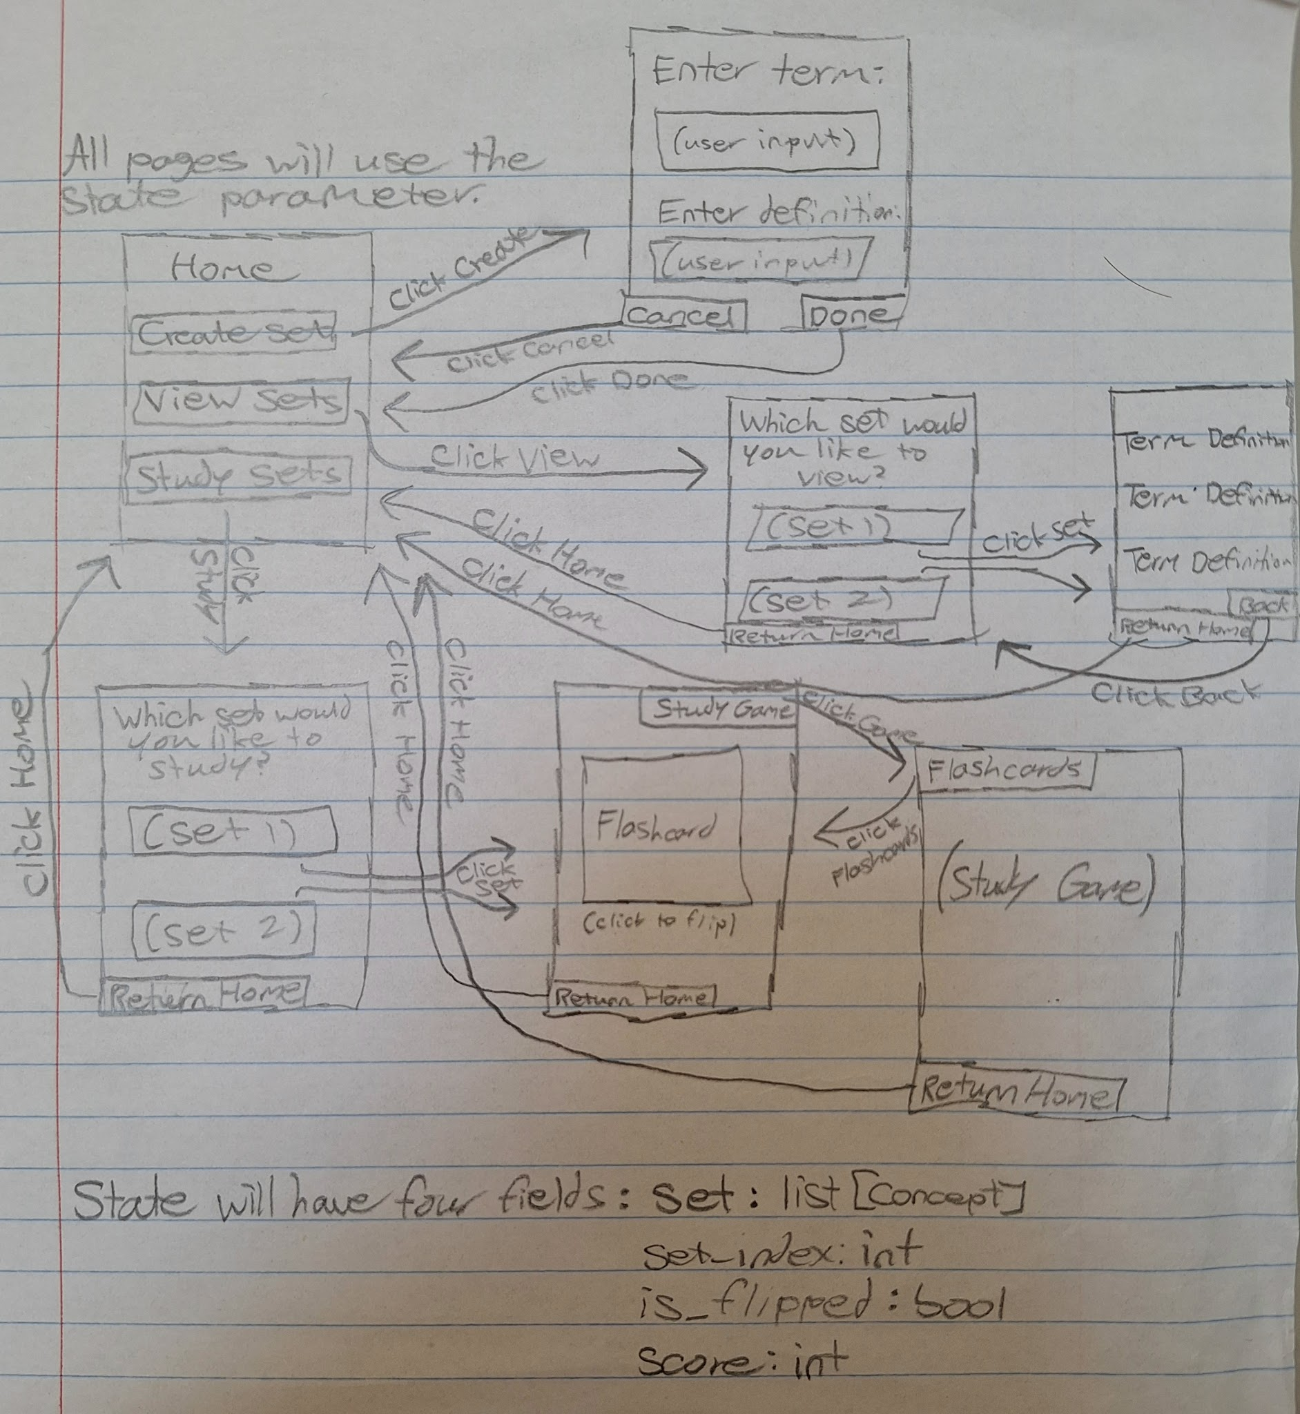
2) Implementing Requirements
This table should serve as a draft for how you will implement the requirements into your final project. You may change your ideas later on, but your final site must fulfill all the requirements.

Requirement | Implementation
Purpose/Functionality  A 1-2 sentence description of the purpose or functionality of your site | My site will allow the user to study information, either inputted or from existing resources, in several ways, such as flashcards or a study game.
State Dataclass Attributes  Minimum of 4 attributes, one of which must be a list/dict of instances of your second dataclass.  Briefly describe each attribute, its type, and how it will be meaningfully modified throughout the site. | - set: list[Concept] - The concepts that the user has created.  - set_index: int - Tracks which set the user has selected.  - is_flipped: bool - Tracks if the presented flashcard is currently flipped.  - score: int - Tracks the user’s score in the study game.
Second Dataclass  Your second dataclass, including its attributes, their types, and how they will be meaningfully modified (if they are modified) | class Concept:  term: str  definition: str  Each concept that the user creates will be stored in a list. This could be modified if I add a way for the user to edit their created sets.
Routes (minimum 7)  The names of your route functions | home  create_set  view_sets  view_selected_set  study_set  flashcards  study_game
Pages (minimum 5)  A brief description of the pages in your site | Home: The user can choose to create a set, view existing sets, or study sets.  Create Set: The user can create a set here.  View Set Selection: The user can select any sets they have created or any pre-existing sets to view.  View Set: The user can view the set they’ve selected.  Study Set Selection: The user can select a set to study.  Flashcards: The user can study the set they’ve selected through flashcards.  Study Game: The user can study the set they’ve selected through a study game.
User Input (minimum 3)  Description of user input components (TextBox, TextArea, CheckBox, or SelectBox) and their purposes  For more information on these input types, see Drafter Documentation. | There will be two TextBoxes on the Create Set page, one for the term and one for the definition.  There will be at least one TextBox on the Study Game page, allowing the user to enter the answer to a question.
If Statements (minimum 3)  Brief description of what will be evaluated in your if statements and how they will meaningfully change the logic of the site | On the Create Set and Study Game pages, there will be an if statement that prevents the user from entering an empty string. This will prevent blank answers overall and allow the user to re-enter an actual string.  On the Study Game page, there will be several if statements that evaluate if the user’s input is correct (matches the term’s definition). If the user is correct, points will be added to their score.  On the Study Game page, there will be an if statement that evaluates the user’s remaining lives. If the user’s lives reach 0, then the game will end and the user’s score will be displayed.
Loop (minimum 1)  This loop must iterate over the list/dict of dataclass instances in your State attribute.  Description of this loop and why it is meaningful to the site | There will be a for loop on the flashcard page, which will create all of the flashcards from the user’s selected set and allow the user to view them.  There will also be a while loop on the Create Set page, allowing the user to repeatedly enter terms and definitions until they’ve created their entire set.

LLM Conversation
If you used an LLM in any part of this work, copy and paste every part of that conversation below. Otherwise, you may be given a zero for the assignment. Obviously, these words will not all be yours, and this is the exception to the requirement at the top of this assignment that all responses be in your own words. If you did not use an LLM to assist you in this assignment, simply say so below.
I did not use an LLM.

Final Submission
When you are finished, download this file as a Word Document (docx) and upload the file to the appropriate assignment on Canvas.

